Mailing Label How-To
FOLLOW this link: Salt Lake County Recorder (arcgis.com)
- Select Envelope Icon in the top right corner
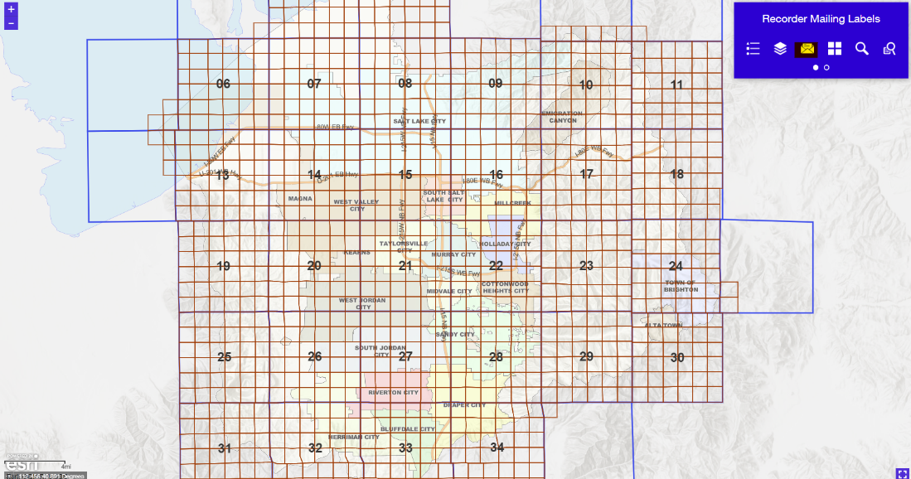

- Enter address in Composite Geocoder search box.
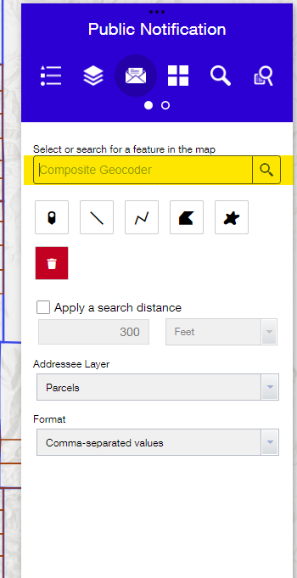
Helpful tool: Address must contain abbreviated direction. Ex: 2001 South State St. Needs to be input as 2001 S State St.

- Select from drop down list.

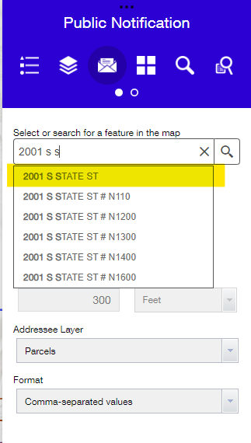
Map will zoom in to parcel
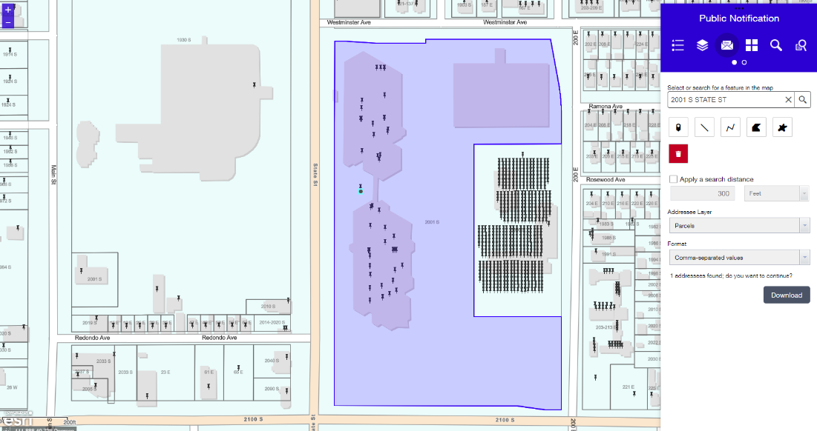
- Click polygon icon.
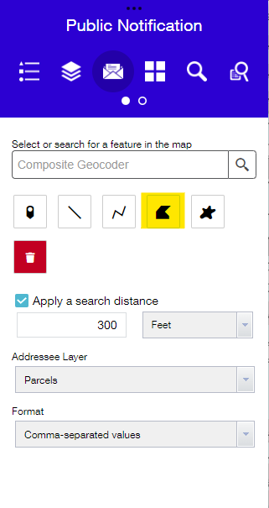
- Outline parcel by clicking corners on map until fully highlighted.

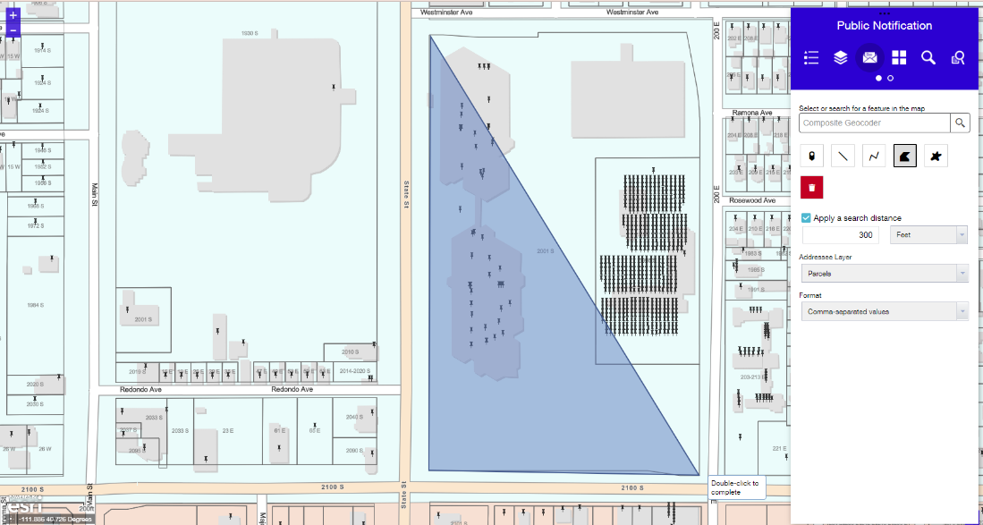
- Double click to end drawing.

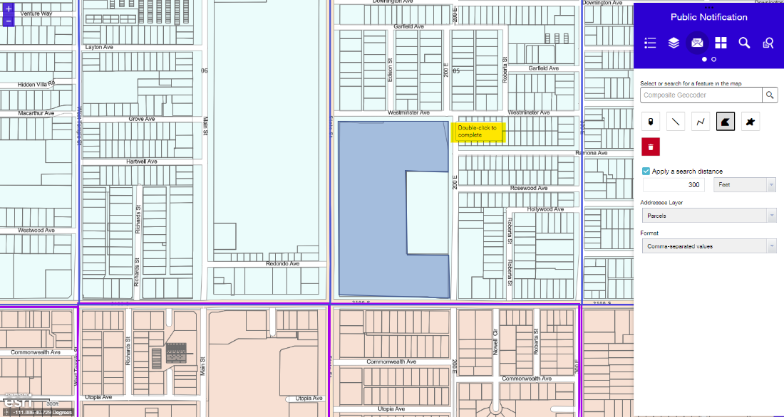

- Select apply a search distance.

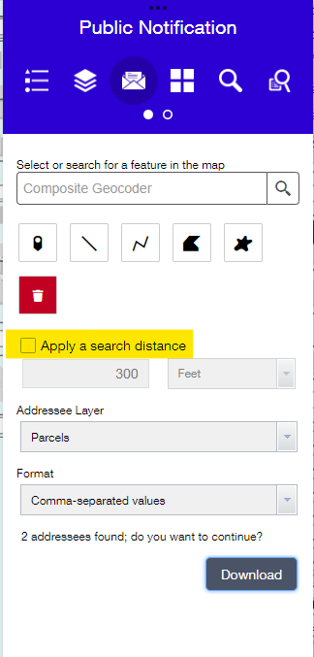

- Area for mailers will be highlighted.

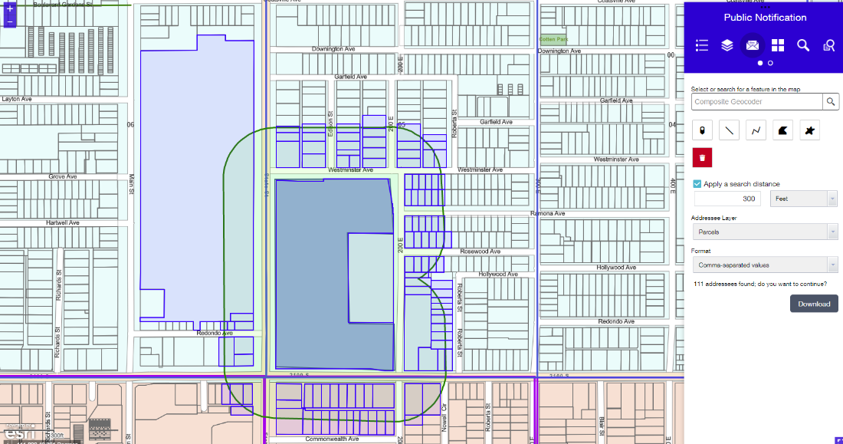

- Select Format drop down list and click PDF label 1 x 2-5/8 inches, 30 per page
- Select Download.

